|  |  |
| --- | --- |
| **FUNCTIONAL APPROVAL SHEET** | |
| Client Name | PT Astra International Tbk |
| Application Name | Mobile FS – Dashboard CMS |
| Function Name | Dashboard – CMS Mobile FS |
| Menu in Application | Group Alert |
| Version | 1.0 |

# Main Success Scenario: Master Data Group Alert

1. **Introduction**
2. This is a new submenu in version v.1.0.
3. This page can be accessed by Admin (Area Leader).
4. This page is used to maintain Group Alert who will receive the News/Alert that has been broadcasted by admin. All user will be injected to CMS, therefore admin only need to maintain the data if there is any changes.
5. **Navigate to Form**
6. To load this form, User must access ‘(link CMS)’, log in to the application, then select ‘Master Data – Group Alert’ as shown below:

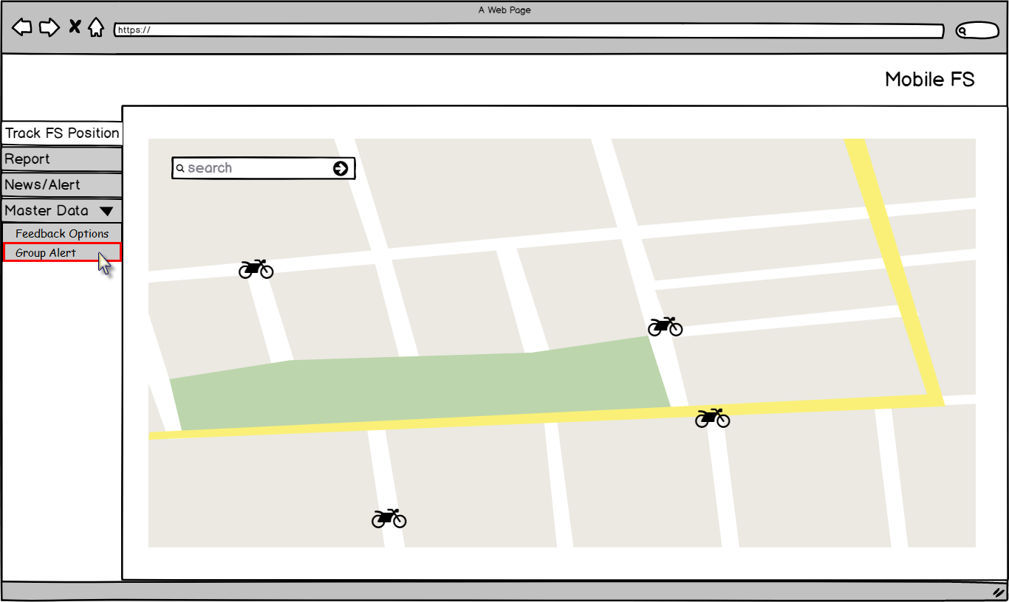

Figure 1 – Navigation to Master ‘Group Alert’ – Mobile FS

1. Application will load following page:

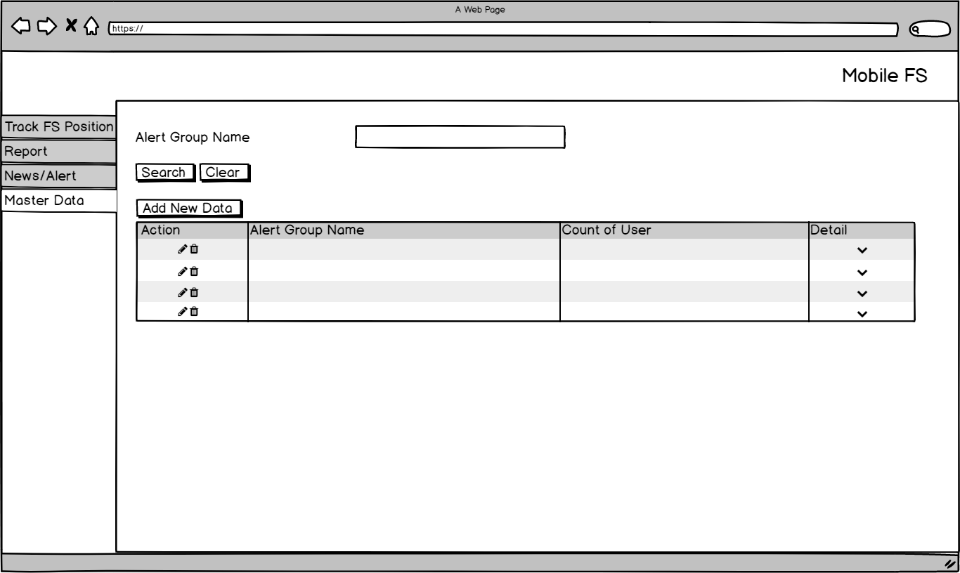

Figure 2 – Master ‘Group Alert’ Form – Master Data

**Condition [Figure 2]:**

* When initially loaded, application will enable following attributes:
* ‘Alert Group Name’ text field.
* ‘Search’ button.
* ‘Clear’ button.
* ‘Add New Data’ button.
* ‘Edit’ button
* ‘Delete’ button.
* Application will disable data grid.
* Data displayed in Master Data Group Alert data grid are data where IsDeleted = 0 and taken from following tables and columns:

|  |  |  |
| --- | --- | --- |
| **COLUMN IN DATA GRID** | **TABLE IN DATABASE** | **COLUMN IN DATABASE** |
| Alert Group Name | AlertGroup | AlertGroupName |
| Count of User | AlertGroup | UserCount |
| Detail |  |  |

* Admin can search Group Alert by typing group name on ‘Alert Group Name’ text field, then click ‘Search’ button. Application will display list of Alert Group that contain the inputted keyword. Application will display list of Group Alert(s) that contain the inputted keyword. Here is the example if Admin search ‘SAP’ (highlighted in yellow):

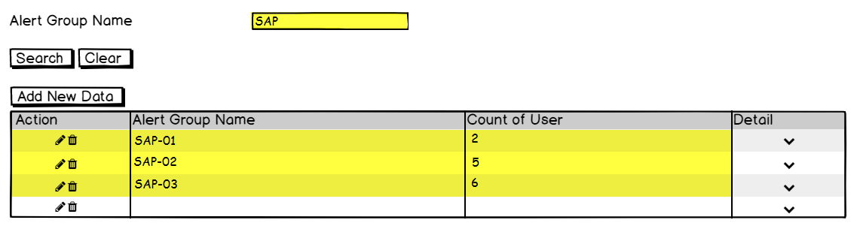

Figure 3 – Search Result – Master Data ‘Group Alert’

Admin can clear the value on ‘Search’ text box by clicking ‘Clear’ button, and then application will re-display the entire data

1. **Function Provided in Form**

In this form, User can view, add, edit, and delete data as follow:

1. View data.

To view list of existing data, Admin must do following steps:

* 1. Log in to the application, then select ‘Master Data – Group Alert’ as shown below:



Figure 4 – Navigation to Master ‘Group Alert’

* 1. Then application will display list groups in a following page as shown below:



Figure 5 – Master ‘Group Alert’ Form – Master Data

* 1. Admin clicks, detail ‘**v**’ button, then application will display detail of list user in selected group:

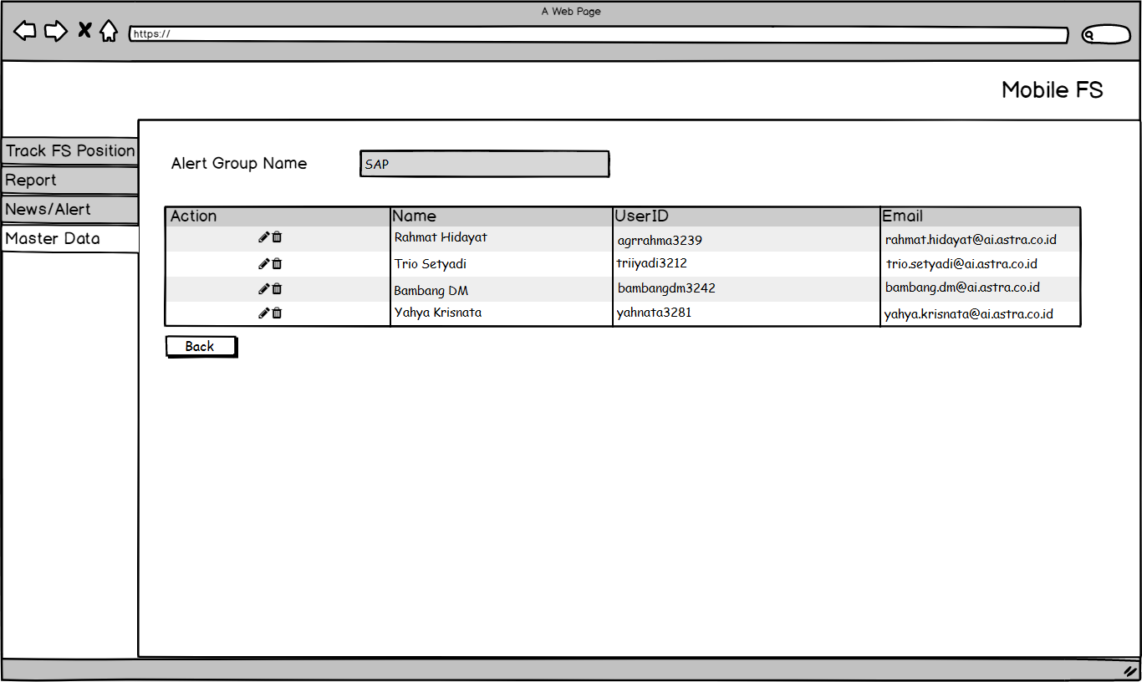

Figure – View Group Detail – Master Data ‘Group Alert’

1. Add data.

To add new data, Admin must do following steps:

1. Admin clicks ‘Add New Data’ and application will display following page:

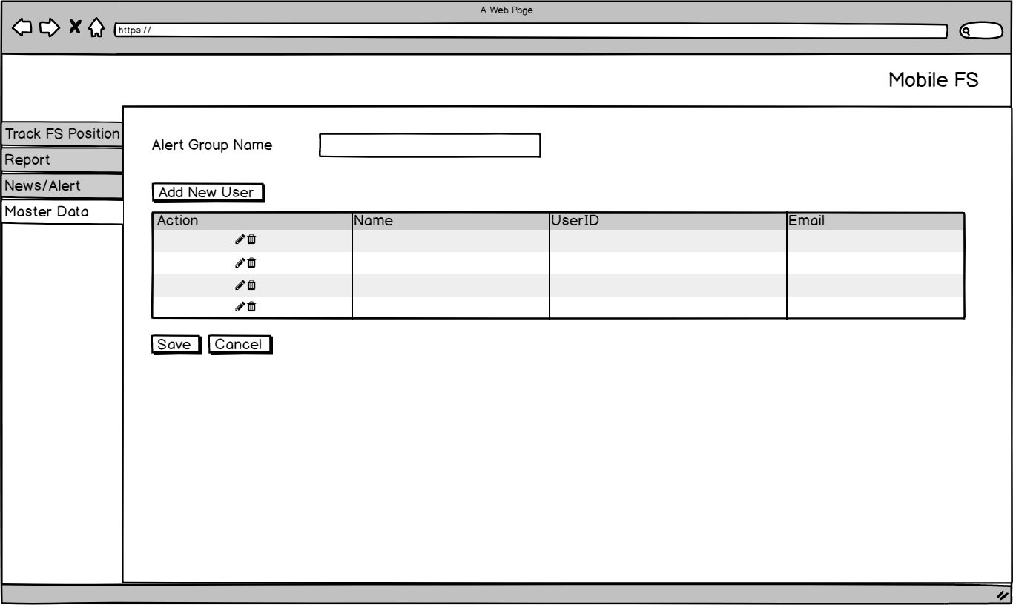

Figure 7 – ‘Add New Data’ Form – Master Data ‘Group Alert’

1. Admin inputs the group name in ‘Alert Group Name’ text field.

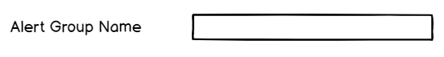

Figure 8 – ‘Alert Group Name’ Text Field – Master Data ‘Group Alert’

**Condition [Figure 7]:**

* This is a mandatory field.
* This field can be filled with alphanumeric.

1. If admin wants to add new user, clicks ‘Add New User’ button, then application will display following pop up menu:

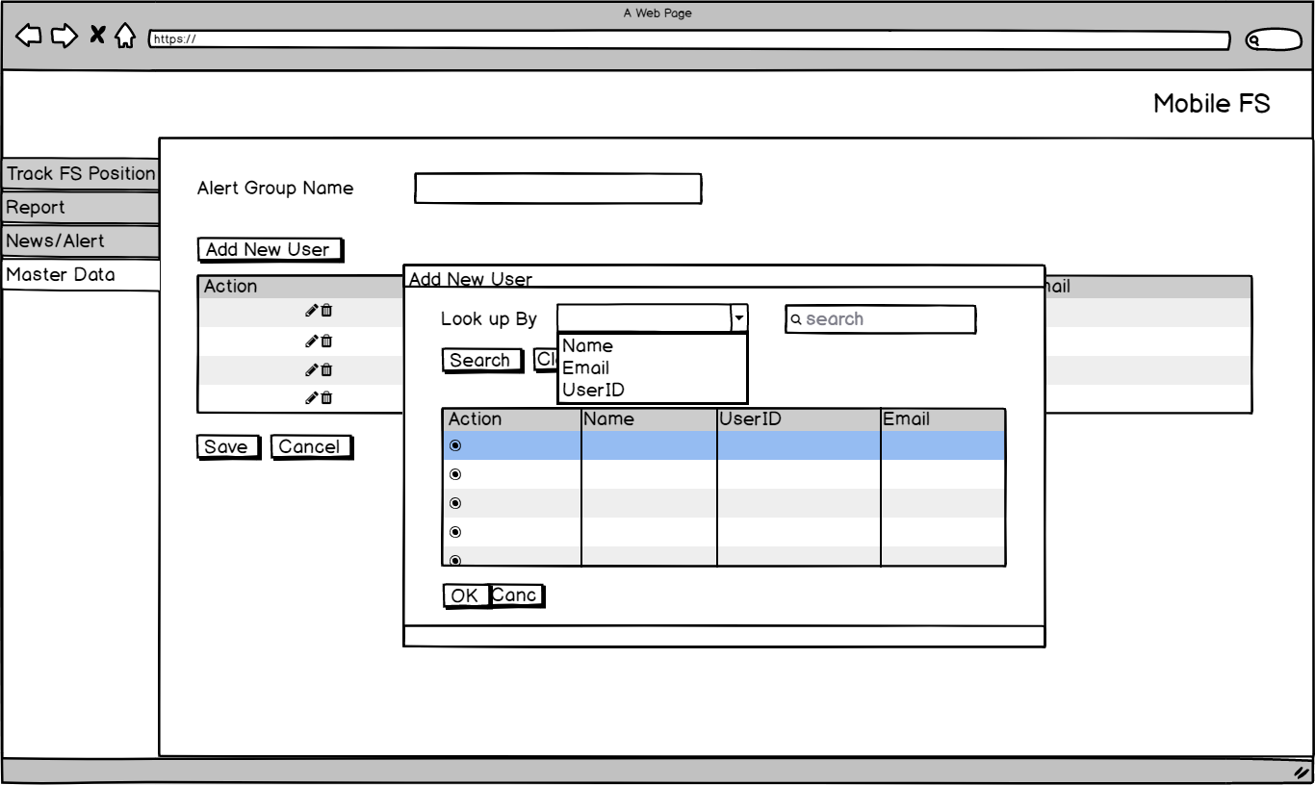

Figure 9 – ‘Add New User’ Pop up Form – Master Data ‘Group Alert’

**Condition [Figure 8]:**

* All users will be displayed when this page is displayed.

1. Admin can search user in ‘Search’ text field as shown below:

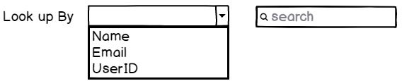

Figure 10 – ‘Look up By’ Dropdown Menu & ‘Search’ Text Field – Master Data ‘Group Alert’

**Condition [Figure 9]:**

* This is not a mandatory field.
* ‘Search’ text field can be filled with alphanumeric.
* Default value of ‘Look up By’ combo box is ‘Name’.

1. Admin clicks ‘Search’ button, then application will display result that match with the search keyword:

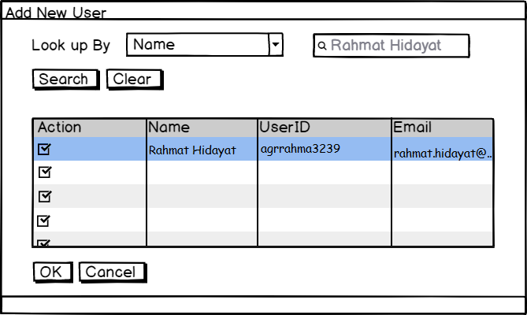

Figure 11 – ‘Search Result’ Pop up Form – Master Data ‘Group Alert’

**Condition [Figure 10]:**

* Application will display data that contains the search keyword.
* Admin can selects multiple data by ‘tick’ the ‘Action’ check box.

1. If admin clicks ‘OK’ button, list of user that has been selected will be added to Master Data – Group Alert (Add New Data) data grid.
2. If admin clicks ‘Cancel’ button, list of user that has been searched and selected will be canceled.
3. Admin clicks ‘Save’ button, then application will apply following conditions:
4. Check whether mandatory field has been filled.
5. If the validation has passed successfully, then the inputted data will be inserted into following tables:
   * + 1. **AlertGroup** table in following columns:

|  |  |
| --- | --- |
| **COLUMN IN DATABASE** | **DESCRIPTION** |
| ID | Auto generated by system. |
| RowStatus |  |
| AlertGroupName | Inputted Alert Group Name. |
| UserCount | Total of user in this group. |
| CreatedBy | Username who creates this data |
| CreatedOn | Date when data has been created |
| ModifiedBy | Empty / blank |
| ModifiedOn | Empty / blank |
| TimeStatus |  |

* + - 1. **AlertGroupProfile** table in following columns:

|  |  |
| --- | --- |
| **COLUMN IN DATABASE** | **DESCRIPTION** |
| ID | Auto generated by system. |
| RowStatus |  |
| AlertGroupID | ID of related alert group. |
| ProfileID | ID of related profile. |
| CreatedBy | Username who creates this data |
| CreatedOn | Date when data has been created |
| ModifiedBy | Empty / blank |
| ModifiedOn | Empty / blank |
| TimeStatus |  |

1. The Master ‘Group Alert’ data grid will have following conditions:

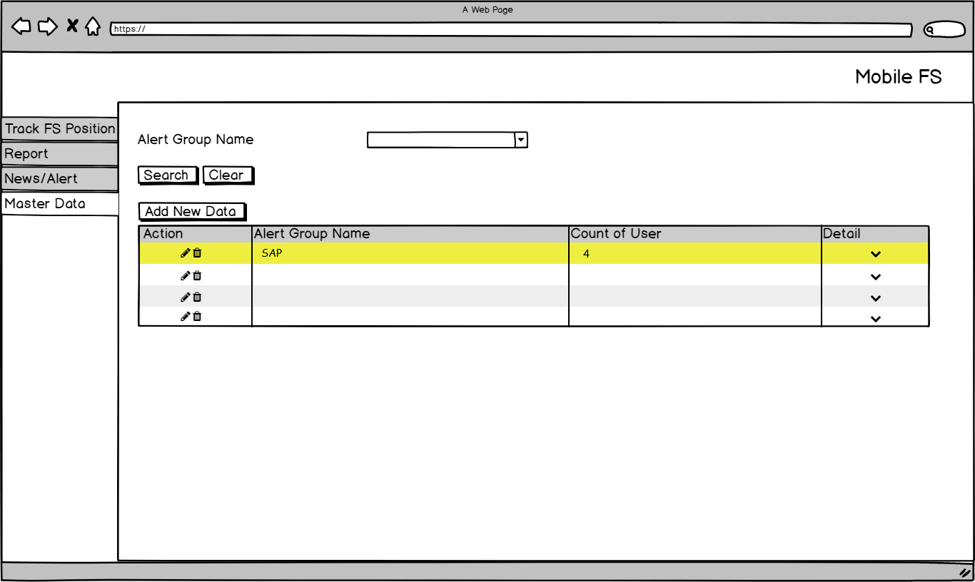

Figure 12 – Master ‘Group Alert’ Form – Master Data

1. If Admin clicks ‘Cancel’ button, then application will go back to the previous page.
2. Edit data.

To edit data, Admin must do following steps

1. Admin clicks ‘Edit’ button in data grid, and application will display following page:

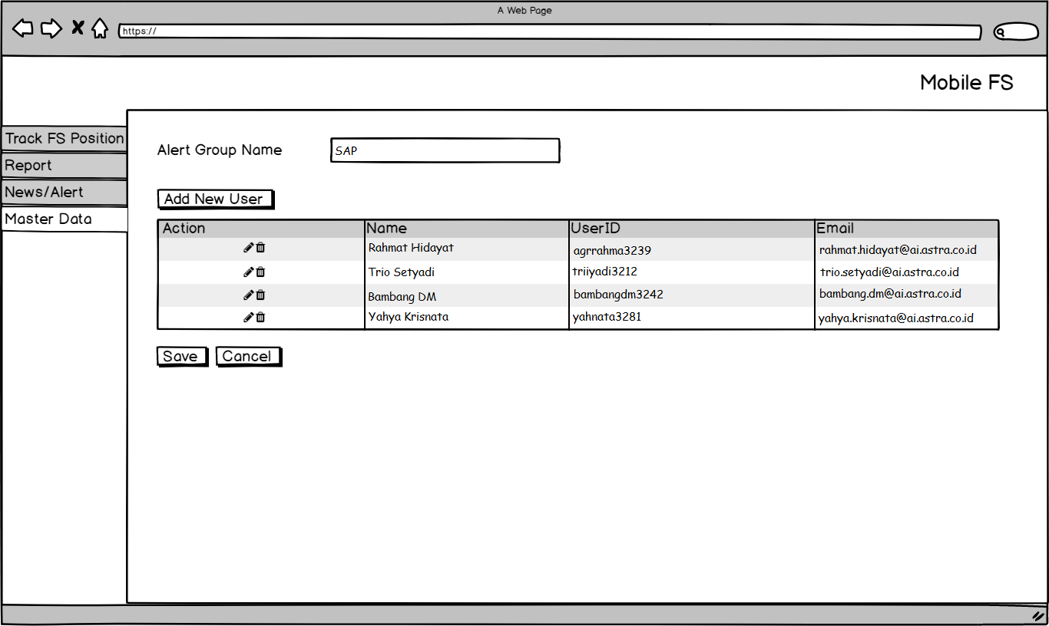

Figure 13 – ‘Edit Group’ Form – Master Data ‘Group Alert’

1. Admin edits the group name in ‘Alert Group Name’ text field.

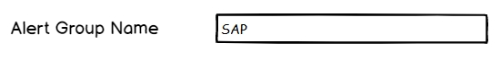

Figure 14 – ‘Alert Group Name’ Text Field – Master Data ‘Group Alert’

**Condition [Figure 13]:**

* This is a mandatory field.
* This field can be filled with alphanumeric.
* The ‘Alert Group Name’ can’t have the same name with other groups.

1. If admin wants to add new user, clicks ‘Add New User’ button, then application will display following pop up menu.



Figure 15 – ‘Add New User’ Pup up Form – Master Data ‘Group Alert’

**Condition [Figure 14]:**

* All users will be displayed when this page is displayed.

1. Admin can search user in ‘Search’ text field as shown below.



Figure 16 – ‘Look up By’ Dropdown Menu & ‘Search’ Text Field – Master Data ‘Group Alert’

**Condition [Figure 15]:**

* This is not a mandatory field.
* ‘Search’ text field can be filled with alphanumeric.

1. Admin clicks ‘Search’ button, then application will display result that match with the search keyword:



Figure 17 – ‘Search Result’ Pop up Form – Master Data ‘Group Alert’

**Condition [Figure 16]:**

* Application will display data that contains the search keyword.
* Admin can selects multiple data by ‘tick’ the ‘Action’ check box.

1. If admin clicks ‘OK’ button, list of user that has been selected will be added to Master Data – Group Alert data grid.
2. If admin clicks ‘Cancel’ button, list of user that has been searched will be canceled.
3. Admin clicks ‘Save’ button, then application will apply following conditions:
4. Check whether mandatory field has been filled.
5. If the validation has passed successfully, then the edited data will be inserted into following tables:
   * + 1. **AlertGroup** table in following columns:

|  |  |
| --- | --- |
| **COLUMN IN DATABASE** | **DESCRIPTION** |
| ID | Auto generated by system. |
| RowStatus |  |
| AlertGroupName | Edited Alert Group Name. |
| UserCount | Total of user in this group. |
| CreatedBy | Username who creates this data |
| CreatedOn | Date when data has been created |
| ModifiedBy | Username who edited this data |
| ModifiedOn | Date when data has been edited |
| TimeStatus |  |

* + - 1. **AlertGroupProfile** table in following columns:

|  |  |
| --- | --- |
| **COLUMN IN DATABASE** | **DESCRIPTION** |
| ID | Auto generated by system. |
| RowStatus |  |
| AlertGroupID | ID of related alert group. |
| ProfileID | ID of related profile. |
| CreatedBy | Username who creates this data |
| CreatedOn | Date when data has been created |
| ModifiedBy | Username who edited this data |
| ModifiedOn | Date when data has been edited |
| TimeStatus |  |

1. The Master ‘Group Alert’ data grid will have following conditions.

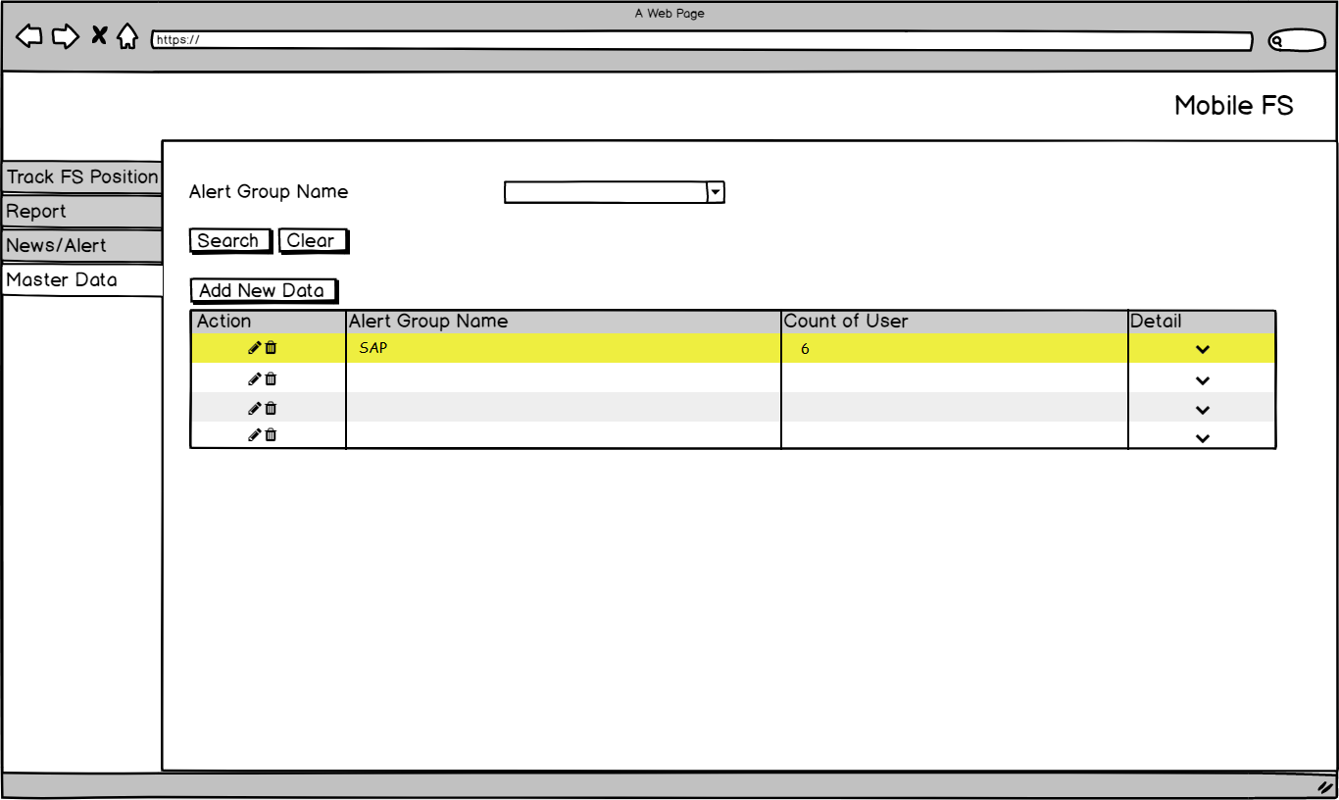

Figure 18 – Master ‘Group Alert’ Form – Master Data

1. If Admin clicks ‘Cancel’ button, then application will go back to the previous page and cancel all changes.
2. Delete data.
   1. Admin clicks ‘Delete’ button in data grid, and application will display confirmation message as shown below:

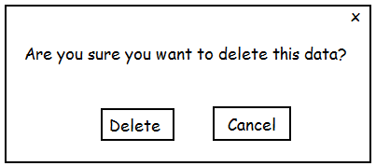

Figure 19 – ‘Delete’ Confirmation Message – Master Data ‘Group Alert’

* + 1. If Admin clicks ‘Delete’ button, then application will apply following conditions:
       1. Update the selected data IsDeleted = 0 into IsDeleted = 1.
       2. Remove the selected data from Master Group Alert data grid.
    2. If Admin clicks ‘Cancel’ button, then application will go back to previous page.

# Extension

When ‘Search’ button is clicked in Search function:

1. If Alert Group Name text field is empty, following message will be shown:



Figure – Error Message – Master Data ‘Group Alert’

When ‘Save’ button clicked in Add and Edit functions:

1. If ‘Alert Group Name’ text field is empty, following message will be shown:



Figure 21 – Error Message – Master Data ‘Group Alert’

When ‘Search’ button clicked in Add New User functions:

1. If ‘Search’ text field is empty, following message will be shown:

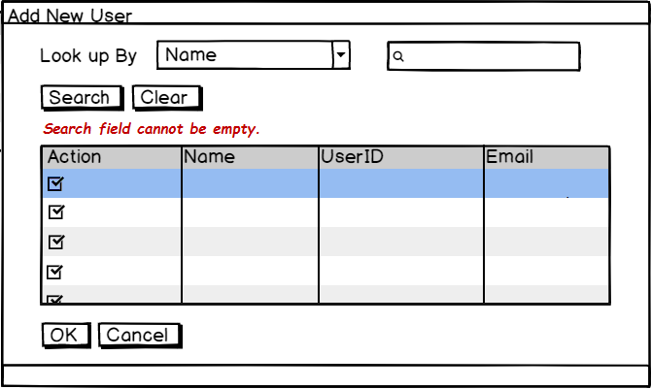

Figure 22 – Error Message – Master Data ‘Group Alert’

1. If there is no search result, following message will be shown:

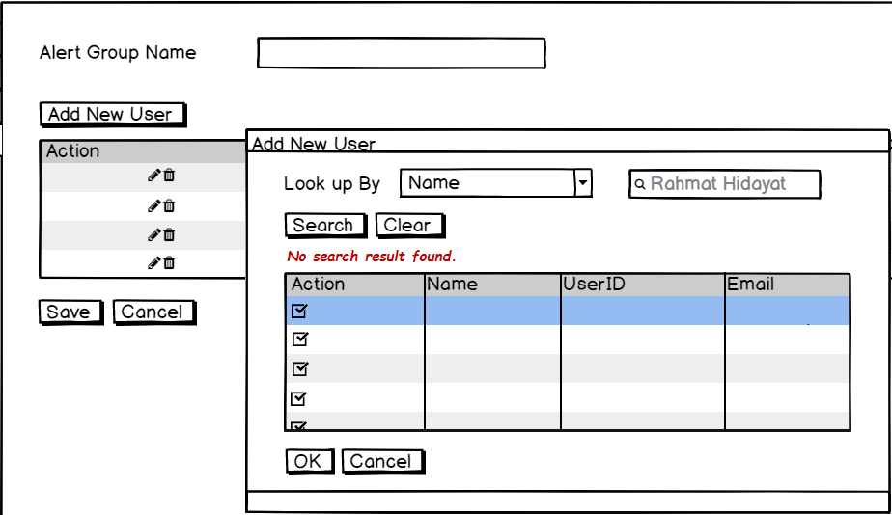

Figure 23 – Error Message – Master Data ‘Group Alert’

When ‘OK’ button clicked in Add New User functions:

1. If there is no selected data, following message will be shown:

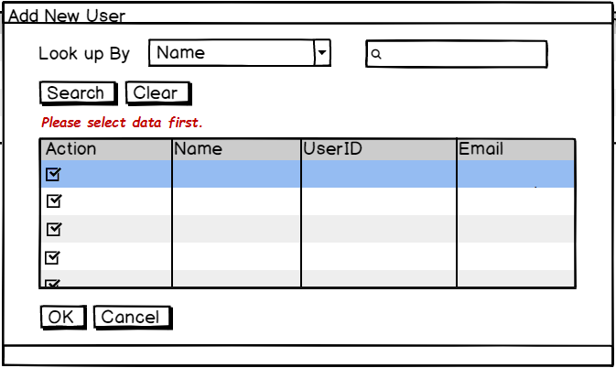

Figure 24 – Error Message – Master Data ‘Group Alert’

|  |  |  |  |
| --- | --- | --- | --- |
| PREPARED BY | REVIEWED BY | | APPROVED BY |
|  |  |  |  |
| Name: Rizky Fitriandini | Name: Yongkie Saputra | Name: Rahmat Hidayat | Name: Arif |
| Moonlay Business Analyst | Moonlay Project Manager | Product Manager | Project Owner |
| Date: March 20th, 2018 | Date: April 10th, 2018 | Date: | Date: |

Copyright © Moonlay Technologies. All Rights Reserved.